Name: Syed Aazmir Hussain
Roll No: 24K-0945
Instructor: Mr. Mubashir
Course: DLD Lab
Lab No: 3

Post Lab Qs 1:

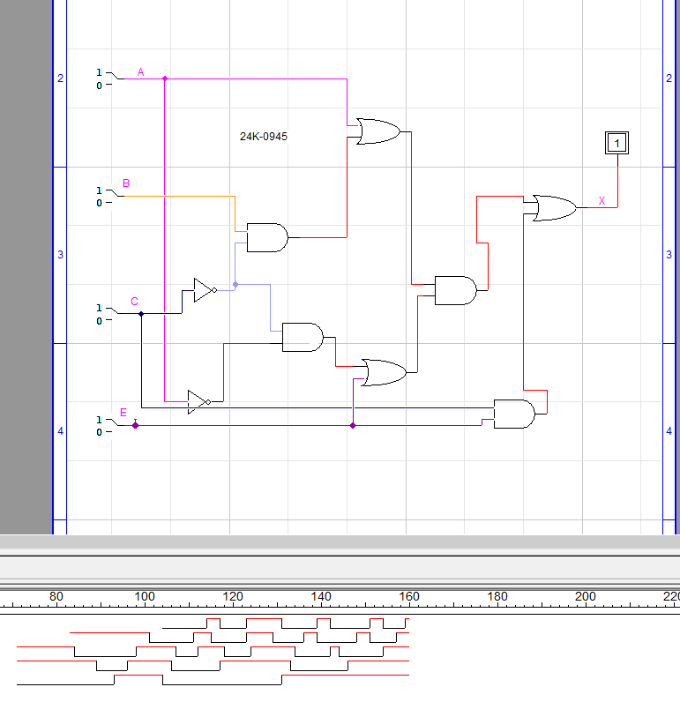

Truth Table
A | B | C | D | X
0 | 0 | 0 | 0 | 1
0 | 0 | 0 | 1 | 1
0 | 0 | 1 | 0 | 1
0 | 0 | 1 | 1 | 1
0 | 1 | 0 | 0 | 1
0 | 1 | 0 | 1 | 1
0 | 1 | 1 | 0 | 0
0 | 1 | 1 | 1 | 1
1 | 0 | 0 | 0 | 1
1 | 0 | 0 | 1 | 1
1 | 0 | 1 | 0 | 1
1 | 0 | 1 | 1 | 1
1 | 1 | 0 | 0 | 1
1 | 1 | 0 | 1 | 1
1 | 1 | 1 | 0 | 0
1 | 1 | 1 | 1 | 1

Post Lab Task Qs 3
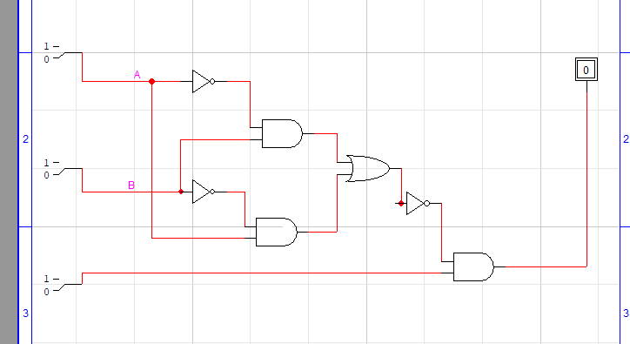

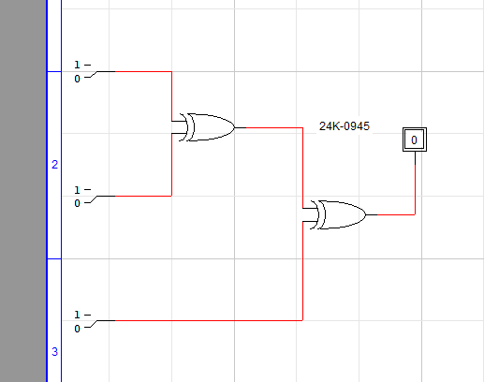

A | B | C | A’ | B’ | C’ | A’B = X | B’A = Y | X+Y = D | D’ | D’C = R | D.C’ = Q | Z
0 | 0 | 0 | 1 | 1 | 1 | 0 | 0 | 0 | 1 | 0 | 0 | 0
0 | 0 | 1 | 1 | 1 | 0 | 0 | 0 | 0 | 1 | 1 | 0 | 1
0 | 1 | 0 | 1 | 0 | 1 | 1 | 0 | 1 | 0 | 0 | 1 | 1
0 | 1 | 1 | 1 | 0 | 0 | 1 | 0 | 1 | 0 | 0 | 0 | 0
1 | 0 | 0 | 0 | 1 | 1 | 0 | 1 | 1 | 0 | 0 | 1 | 1
1 | 0 | 1 | 0 | 1 | 0 | 0 | 1 | 1 | 0 | 0 | 0 | 0
1 | 1 | 0 | 0 | 0 | 1 | 0 | 0 | 0 | 1 | 0 | 0 | 1
1 | 1 | 1 | 0 | 0 | 0 | 0 | 0 | 0 | 1 | 1 | 0 | 1

Post Lab Task Qs 2
Prove:
- A + AB = A B) (A + B) (A + C) = A + BC
A (1 + B) A.A +AC + AB + BC
A (1) A + AC + AB + BC
= A A (1 + C + B) + BC
Hence A + AB = A A (1) + BC
= A + BC
Hence (A + B) (A + C) = A + BC

